Positive and Negative Effects of Social Media on Social Interactions

***Naida Demirović  
Dżemal Bijedić University  
Faculty of Information Technologies***

***Mostar, Bosnia and Herzegovina***

***naida.demirovic@edu.fit.ba***

*Abstract*—**Influence of social media on social interactions can be seen as both positive and negative. Increase in usage of social media in everyday communication has changed the way people interact with each other. Although it offers easier and faster way to connect and communicate with people on one hand, on the other hand this way of communication lacks intimacy and knowledge of nonverbal communication, and on long term can cause serious brain damage. Therefore, social media undermines the real meaning of social interaction for new generations.**

***Keywords—* *social interaction, social media, positive and negative effects***

1. Introduction

In general, social media covers computer-**media**ted tools and applications that allow people to create, share or exchange information, ideas, pictures and videos in virtual communities and networks in real time irrespective of time or distance barriers [7].

Usage of social media has become very popular not only among teenagers and students but among members of all generations with different backgrounds, so today it is almost impossible to neglect importance of social media in everyday life. From the aspect of social interaction, usage of social media offers quick and simple way to reconnect with friends and family around the world, find new friends and share ideas and concerns among wider audience. On the other hand, the diversity of entertainments in social media sites might cause an individual over spending time on the computer or smartphone [2].

Nowadays, as we have different ways of transferring information, the question is do people really communicate and what the quality of those communications really is. The fact that we can be online most of the day enables us to instantly be aware of the news and be available for other people. At the same time this influences on privacy and also forms addiction, where we feel that we need to follow the news and statuses all the time. Furthermore, constant using of social networks makes our lives and all the activities become virtual simulation of real life. In real life constant usage of social media makes people alienate from each other and makes them physically become inactive for new and outdoor activities.

1. SOCIAL MEDIA

Social media has become an integral part of everyday life of millions of persons around the world. It enables us to stay in touch with persons we don’t have the opportunity to see every day, and it enables us to have access to basic information as quick as possible. It is certain that social media has a wider and faster means of transferring information to wider population [6].

Different studies showed that usage of social media has both positive and negative influence on consumers [1]. A lot of people become uncomfortable with face-to-face communication. More and more people show that they are over rely on using social media to communicate with each other. Increased usage of social media can influence decision making as well as behavior. Usage of social media enables us to have an insight in lives of others which can make us become unsatisfied with our own.

As it can be seen on the Fig 1. above usage of social networking sites among youth is mainly based on staying in touch with friends, and not using its advantages that are related to professional actives and/or interest groups.

Increased usage of social media for interaction makes many people get involved in an abundant number of relationships through technology, but sometimes the quantity of these associations leaves people feeling qualitatively empty [1]. Today, it is important to have thousands of so called ‘friends’ on social networks among which there is a huge number of ones that we have never spoken a word to. All this gives wrong meaning of friendship and human interactions in general to new generations.

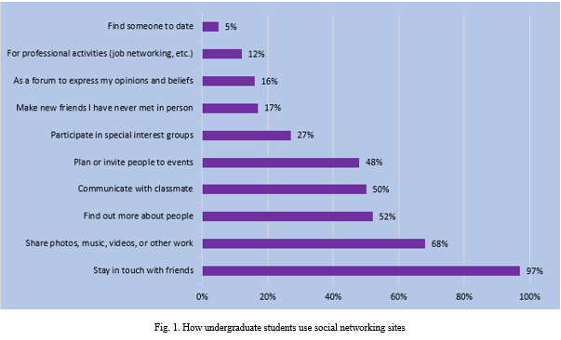

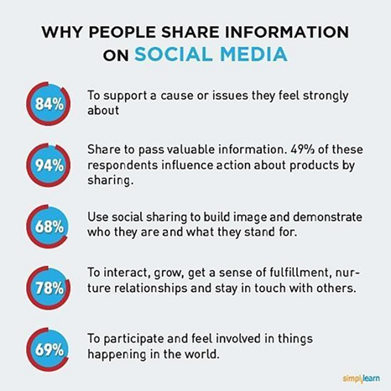

Fig. 2. Why people share information on social media

Furthermore, social media, apart from the main reasons for usage described on the image above, is nowadays used by companies to influence customers’ needs and behaviour. As almost a quarter of the world’s population is now on Facebook and other social networks, it is a perfect platform that can be used by various actors with the aim to influence people’s mind and decision-making.

1. Positive effects

Nowadays, different studies are conducted in order to evaluate influence of social media, covering both positive and negative ones. Among positive effects certainly are the ones that enable us to communicate with friends and family, get up to date information, be included in interest groups etc. Usage of social media allows young people to connect with people around the world and thus learn about new traditions, way of life and meet new friends. It helps them acquire a broader perspective on life and people in general [1].

From the aspect of social interaction, usage of social media enables us to avoid face to face communication which also includes nonverbal communication, which has positive effect on shy persons and enables a person to express its opinion in simpler way. Various studies have shown that social media makes people more empathetic, considerate and relationship-oriented.

Furthermore, social media is commonly used by students to form study groups, share information and support each other. Today, almost every class and school has its own group on social network which enables its members to get instant information about important topics. Different studies have shown that this way, especially teenagers, feel more connected to their classmates.

1. NEGATIVE EFFECTS

As usage of social media is becoming an integral part of everyday life, different studies are conducted and show an increase of negative effects of its usage, especially on social interactions. As it is often described, social networks are everything but not socializing in its real meaning.

The simplest explanation of negative effects of social media on social interaction is the picture we all see every day where we have a couple or a group of individuals sitting together and not talking to each other but rather looking at their smartphones. Communication is nowadays mostly based on messages sent over social networks.

Apart from positive effects already mentioned, social media can also have a range of negative effects on teenagers, which include brain development. Research indicates that teenagers who spend more than 2 hours a day on social media are more likely to experience mental health problems such as psychological distress [8]. Furthermore, different studies have shown that uncontrolled usage of social networks causes addiction.

What is also important to mention is that communication over social media, which involves commenting posts and giving ‘likes’, has become a criteria of success. Absence of expected effect on our post on the social networks can cause sense of less value, sorrow, even phobia [9].

Usage of social media in its form and shape, which is based on nonverbal communication can influence development of behavior which is not applicable in offline world. Hence children growing up interacting mostly with social media may turn out non-empathetic and also become poor at communicating verbally and nonverbally [5].

Spending too much time communicating on social media and not communicating face to face, makes introverts and persons that are not able to communicate in outside world. They are not able to understand nonverbal communication and other people’s moods and emotions. This all represents a major risk for depression and suicide.

The term ‘friend’ as used on social media lacks the intimacy unlike as it is a case with traditional friendship where persons actually talk to each other mainly face to face and share privacy [4]. Furthermore, constant looking at other people’s posts on social media, which nowadays is not necessarily a picture of real life, makes a person become unsatisfied with its own life and can often lead to despair.

1. CONCLUSION

Presences of social media in everyday communication is something that is increasing constantly and therefore cannot be neglected. What we can see every day is that people are becoming dependent with this technology constantly.

According to Forbes magazine, only 7% of communication is based on the verbal word. That means that over 90% of communication is based on nonverbal cues such as body language, eye contact, and tone of voice, which certainly is not the case with interactions over social media [3].

Moreover, the fact is that students generally utilize slang words or abbreviated types of words on long range interpersonal communication levels. This decreases their basic writing abilities [6].

As like with everything else, usage of social media can be beneficial or misused, depending of the approach. The fact is that social media enables us to be in contact with our friends, family, classmates etc., and provides us with possibility to communicate more conveniently in general. On the other hand, it causes different changes on human behaviour.

Social media has created many social problems in the society. In these modern days, many students tend to choose online communication rather than having real time conversation, and this leads to students becoming an introvert [6].

As various researches have been conducted, emphasizing both positive and negative effects of social media on social interaction, it is hard to determine which one has more impact. Therefore, the effect that social media has on each person is different and can only be observed on a case-by-case basis.

***References***

1. Human Kinetics (organization), “Dimensions of Leisure for Life: Individuals and Society”, Chapter 8: “Leisure and Technology”. Human Kinetics, 2010, pp. 161-183.
2. Doris Hooi-Ten Wonga, Chen-Siang Phangb, Nurazean Maarop, Ganthan Narayana Samya, Roslina Ibrahima, Rasimah Che Mohd Yusoff , Pritheega Magalingama, Nurulhuda Firdaus Mohd Azmia, “Effect of Social Media on Human Interpersonal Communication”, CA: Unversiti Tunku Abdul Rahman, Malaysia, 2017
3. Haley Jones, “Social Media's Affect on Human Interaction”, 2013 [Online]

Available:<https://www.hastac.org/blogs/haley117/2013/06/07/social-medias-affect-human-interaction>

1. Maryanne Gaitho, “What Is the Real Impact of Social Media?”, 2018 [Online]

Available: <https://www.simplilearn.com/real-impact-social-media-article>

1. <http://parenting.firstcry.com/>, “Impact of Social Media on Children”, 2018 [Online]

Available: <http://parenting.firstcry.com/articles/impact-of-social-media-on-children/>

1. Ana Maria De La Cruz, “Positive and Negative Use of Social Media by Students”, 2017 [Online]

Available: <http://blog.blogdash.com/media-industry/positive-negative-use-social-media-students/>

1. Mehdi Khosrow-Pour, “Encyclopedia of Information Science and Technology”, Fourth Edition (10 Volumes), 2017
2. Robyn Treyvaud, “The Negative Effects Of Social Media On Teens”, 2017 [Online]

Available: <https://wanglefamilyinsites.com/advice/negative-effects-of-social-media-on-teens/>

1. Jovana Pantovic, “Svi pričamo o štetnosti društvenih mreža, ali jedno zaboravljamo”, 2018 [Online]  
   Available:<https://www.b92.net/tehnopolis/vesti.php?yyyy=2018&mm=01&nav_id=1348325>